PROJECT TITEL: MEDICAL INVENTOTY MANAGEMENT SYSTEM

College Name: KAAMADHENU ARTS AND SCIENCE

College Code: bru4p

TEAM ID: **NM2025TMID21213**

TEAM MEMBERS:

Team Leader Name: **LATHAMBIGA R**

Email: **LATHAMBIGA**.cs23@kascsathy.ac.in

Team Member: **KARTHIKEYAN R**

Email: **KARTHIKEYAN**.cs23@kascsathy.ac.in

Team Member: **KISHOR BALA K**

Email: **KISHOR BALA**.cs23@kascsathy.ac.in

Team Member: **KAVIN N**

Email: [KAVIN.cs23@kascsathy.ac.in](mailto:KAVIN.cs23@kascsathy.ac.in)

**Salesforce Project Documentation**

**Project Title:**

**Medical Inventory Management System**

**Project Description:**

**The Medical Inventory Management System is a comprehensive Salesforce application developed to efficiently manage various aspects of medical inventory operations. This system enables the effective maintenance of supplier details, purchase order management, product tracking, and expiry date monitoring. The solution enhances operational efficiency, ensures data accuracy, and provides powerful reporting capabilities to aid informed decision-making within medical inventory management.**

**Project Objectives:**

**Streamline medical inventory operations using Salesforce**

**Maintain detailed supplier information including contact details**

**Catalog product information such as descriptions and stock levels**

**Track product expiry dates to avoid using expired items**

**Generate comprehensive reports for supplier performance and purchase orders**

**Project Features:**

**Supplier Management**

**Product Management with Stock & Expiry Tracking**

**Purchase Order Management**

**Expiry Date Alerts**

**Comprehensive Reporting**

**Role-based Access Control**

**User Management**

**Automation with Flows and Triggers**

**Validation Rules for Data Accuracy**

**Project Flow & Milestones:**

**Milestone 1 - Salesforce Account**

**Created a Salesforce Developer Account to access and build the application. Understood Salesforce as a customer success platform designed to help sell, service, market, and manage operations efficiently.**



**Milestone 2 - Objects**

**Created custom objects such as Product, Purchase Order, Supplier, Order Item, and Inventory Transaction to store relevant data for managing medical inventory.**

**Milestone 3 - Tabs**

**Added custom tabs for easy access to objects like Product, Supplier, Purchase Orders, etc., ensuring smooth navigation for users.**

**Milestone 4 - The Lightning App**

**Developed a custom Lightning App, combining objects, tabs, and tools to deliver an intuitive, efficient user experience tailored for medical inventory management.**

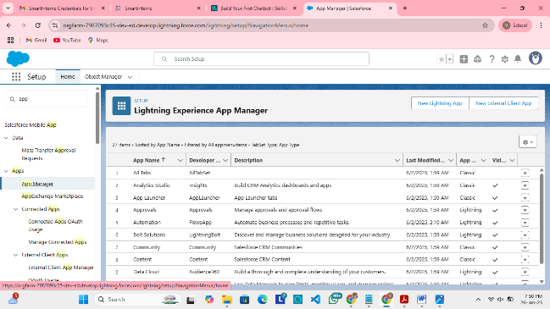

**Milestone 5 - Fields**

**Created necessary fields for each object, including product details, stock levels, expiry dates, order details, supplier information, and transaction details to capture all required data.**

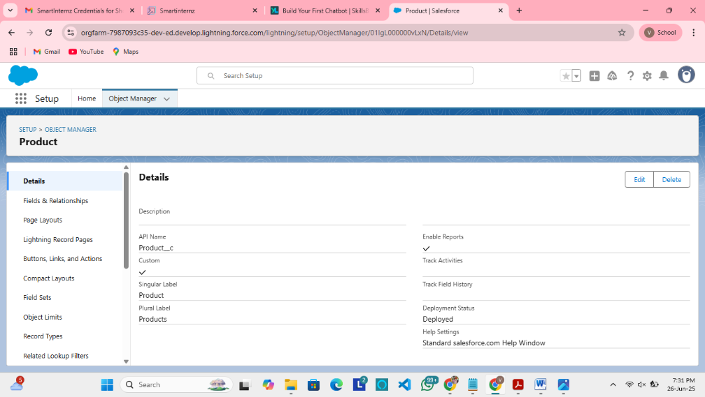

**Milestone 6 - Editing of Page Layouts**

**Customized page layouts for objects to control field visibility, structure, and grouping, ensuring users have access to relevant information in an organized manner.**

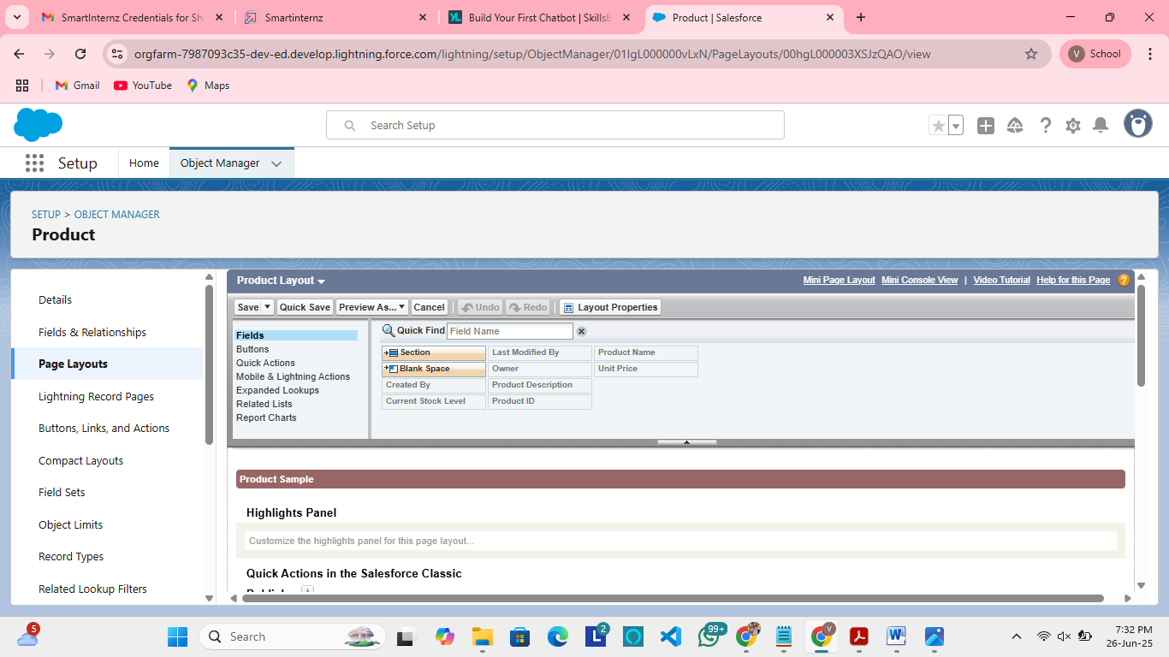

**Milestone 7 - Compact Layouts**

**Designed compact layouts to display key fields at a glance, allowing users to quickly access essential information without opening full records.**

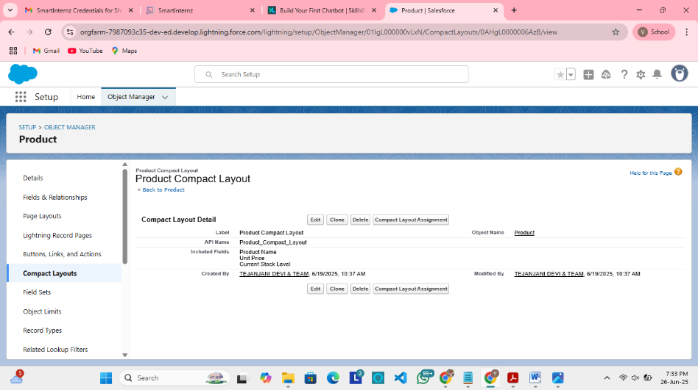

**Milestone 8 - Validation Rules**

**Implemented validation rules to ensure data accuracy and integrity by preventing users from saving incomplete or incorrect records.**

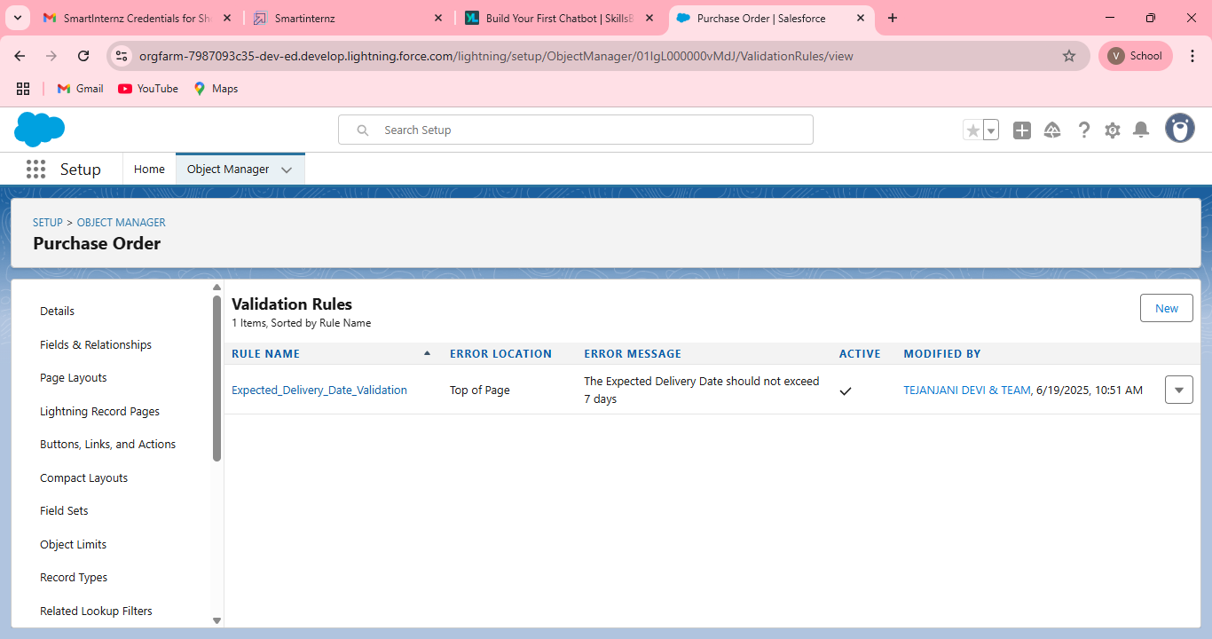

**Milestone 9 – Profiles**

**Configured profiles to define user permissions, controlling what users can view, edit, create, or delete across different objects and features.**

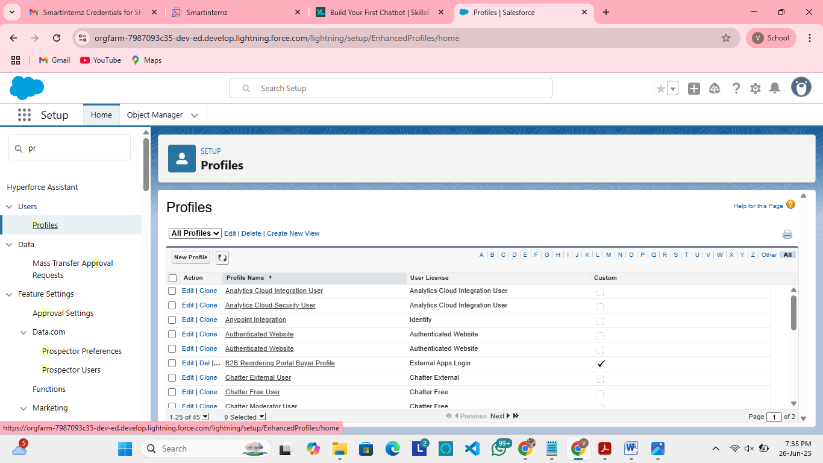

**Milestone 10 - Roles**

**Defined a role hierarchy to control record-level access and ensure appropriate data visibility across different levels of the organization.**

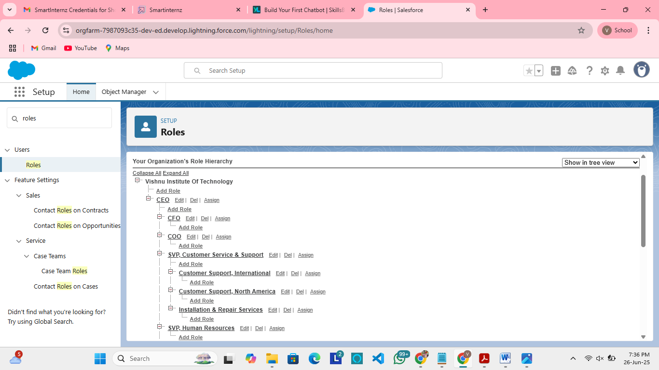

**Milestone 11 - Users**

**Created user accounts, assigned appropriate profiles and roles to ensure secured access to the system based on their responsibilities.**

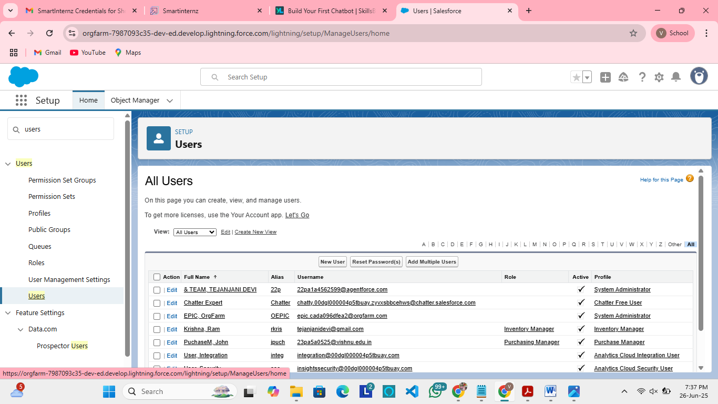

**Milestone 12 - Permission Sets**

**Used permission sets to extend specific user permissions beyond their profiles without affecting overall system security or creating extra profiles.**

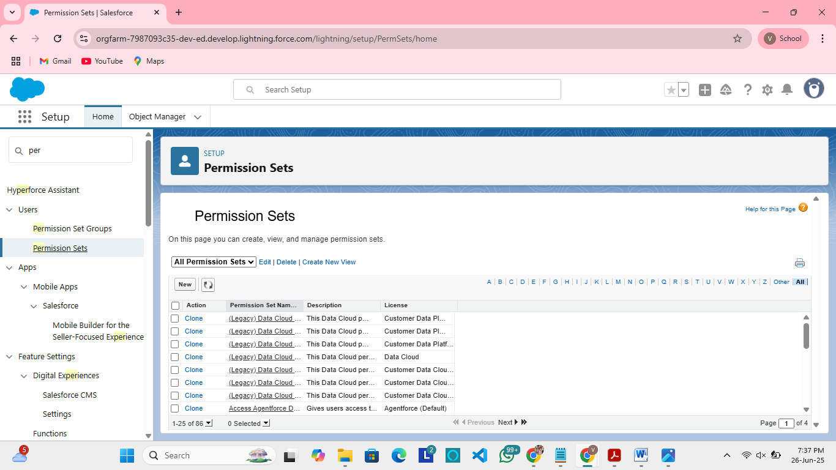

**Milestone 13 - Flows**

**Built flows to automate business processes such as product expiry alerts, purchase order approvals, and supplier notifications without writing code.**

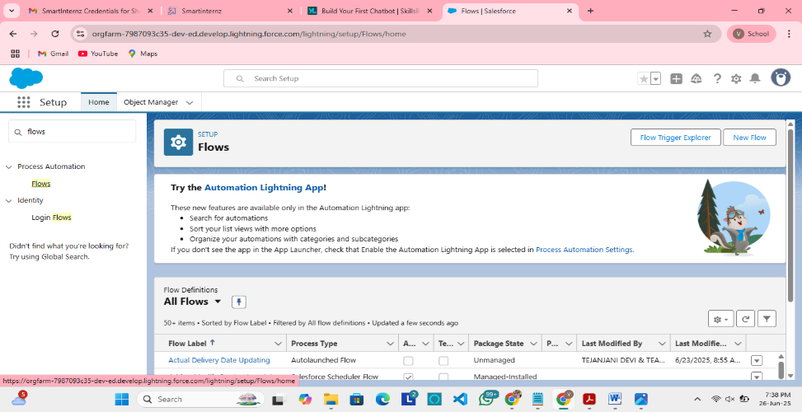

**Milestone 14 - Triggers**

**Developed Apex triggers to handle complex business logic, such as automatic updates of stock levels and calculations that cannot be achieved through point-and-click tools.**

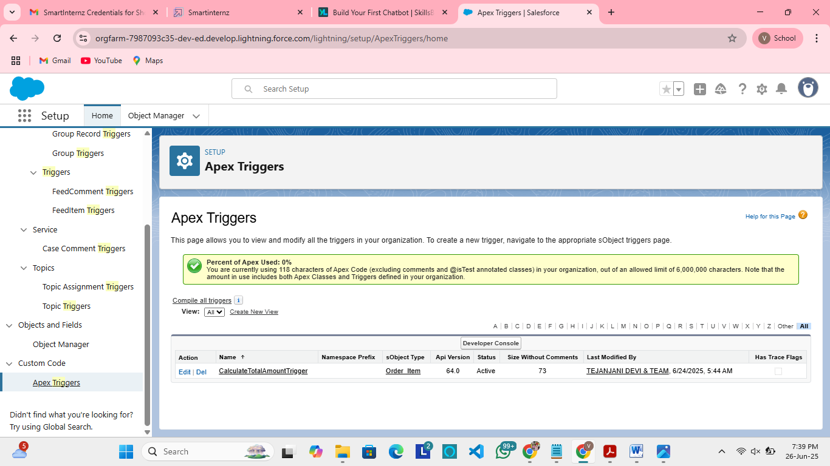

**Milestone 15 - Reports**

**Generated reports for supplier performance, stock levels, order summaries, and expiry tracking to gain actionable insights and support decision-making.**

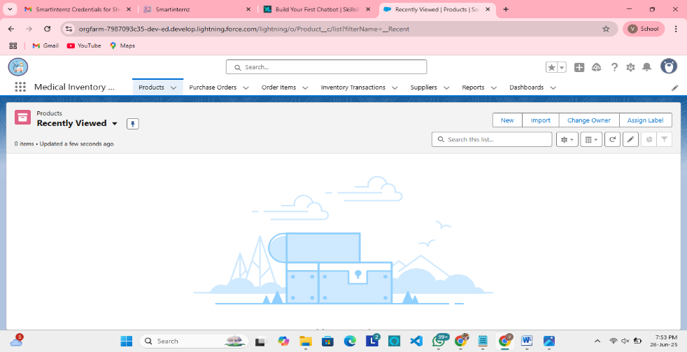

**Milestone 16 - Dashboards**

**Designed dynamic dashboards to visually represent key inventory metrics, supplier performance, and order summaries for quick, real-time monitoring.**

**Technologies & Tools Used:**

**Salesforce Lightning Platform**

**Apex (for Triggers)**

**Flows (Automation)**

**Validation Rules**

**Reports & Dashboards**

**Profiles, Roles, Permission Sets**

**Learning Outcomes:**

**Hands-on experience with a real-time Salesforce project**

**Strong understanding of object relationships and data modelling in Salesforce**

**Proficiency in Page Layout customization and Compact Layouts**

**Knowledge of data validation techniques using Validation Rules**

**Efficient management of user access through Profiles, Roles, and Permission Sets**

**Automation of processes using Flows and Apex Triggers**

**Ability to create insightful Reports and Dashboards for performance tracking**

**Conclusion:**

**The Medical Inventory Management System developed on Salesforce offers a centralized, efficient, and reliable solution for managing medical inventory. Through its robust features, automation capabilities, and user-friendly interface, the system enhances operational efficiency, ensures product tracking, and supports informed decision-making with real-time insights.**